September 18th, 2011
Hi
Not too much to write about. Still plodding along with the books. But still had time to do a bit more swimming, doing 18 km for the five swims, which included two 4 km swims. I did a calculation of all the swims so far this season and the average is a fraction under 2 km per swim, higher than expected. Last year, the overall average was 2.2 km but I was not aiming for that this season. The water temperature is still about 32⁰C so is still rather warm. However, on getting out of the pool, you notice that the air is now cooler so water temperatures will begin to drop soon. A long swim in hot water is very dehydrating and I drink a lot of water in the evening following such a swim.
I saw on the TV news last night that they were having public trials at a pool for the upcoming cross-harbour swim. Had I been aware of this, I would have gone; you had to do 1.5 km in 45 minutes, which is very easy. There were several people there who had participated in the races all those years ago. Previous reports had said that only those who had already participated in ocean swims, and times to prove it, were eligible to apply for the swim. Still, they are only going to accept 1000 for the race.
This past week, the Stanford alumni e-mail website became part of Google e-mail. Still have the same address but, on opening, the layout is the same as for g-mail. Still, I seldom use it for sending mail. I have accumulated about 8 e-mail addresses most of which I never use, and some I couldn't as I have forgotten the passwords.
Did you see on TV, the pictures of the British PM Cameron and the French president in Libya receiving a rapturous reception, more that either would get at home? A pity Obama wasn't there as well; even though the US did not participate directly, it was they who were instrumental in getting multi-lateral action.
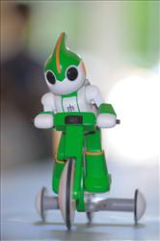
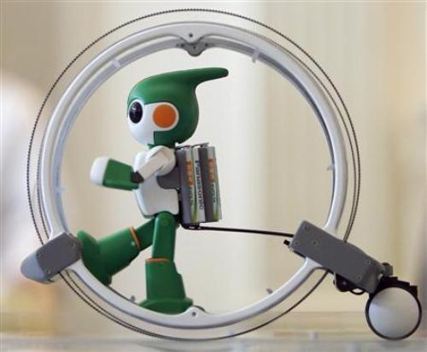
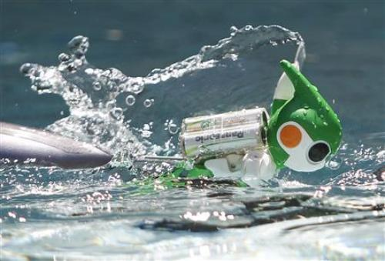
Gavin, you now have a competitor for your Tin-man and Iron-man triathlons in the form of a Japanese hand-sized robot. It is set to tackle the Honolulu iron man distances (though not the actual site) and is expected to take 168 hours. Have a look at the video to see the robot in action:
http://www.telegraph.co.uk/news/newstopics/howaboutthat/8765233/Tiny-Japanese-robot-takes-on-Ironman-triathlon-challenge.html
In the RWC, NZ thrashed Japan 83 - 7 and in something of a surprise, Ireland beat Australia 15 - 6. If you are interested, these is a video of highlights posted every day:
http://www.rugbyworldcup.com/home/news/newsid=2052172.html#best+rwc2011+sept

There is a good joke in this week's Time magazine. It was in an article about Rick Perry and Texas A&M, but can be told independently of that context. It is about the intellectual level of a guy who bragged about finishing a jigsaw puzzle in just 45 days when the box said “2 to 4 years”. Get it?
That’s about it for this week
Cheers

